Middle School Solutions!
Sharon O’Connell, Skaneateles Middle School Library Media Specialist
Christine Dickerson, Skaneateles Middle School Technology Teacher
Maureen Southorn, Syracuse University Library Science Student
IST 611/M001 – Spring 2008
Collaborative Technology Project Final Report

The Project
This project, which initially began as an idea to link Skaneateles Middle School students as e-pals to students in Taiwan, has evolved into a set of three projects, all based on wiki application technology. First, we have set up a Middle School Solutions! wiki using the Wetpaint application for this initial project. Second, we set up a twin site for sharing with a Japanese school group. Third, we have posted a public wiki linked to Memorial Day and Social Studies content area curriculum requirements: students interview World War II veterans, edit, and post these videos to the wiki for sharing with the school and the general public. All three wikis are undergoing constant edit and update from a large community of teachers and students, the mark of a successful Web 2.0 project.

The Team
Sharon and Christine wrote up the initial idea as a grant effort, and I entered the project as the “how-to” specialist. They brought to the project their knowledge of their student population, familiarization with information literacy and technology curriculum requirements, and visionary ideas about what a Web 2.0 activity could offer to the project. I brought to the project the detailed knowledge of wiki applications and how to use them. We all brought with us copious volumes of enthusiasm at the idea of witnessing the ongoing interactivity and student participation this project can offer the school.

Needs Assessment
Our team did not conduct a needs assessment for this project. The two “e-pal” style wikis were self-initiated by Sharon, as she realized that her students were fascinated by the idea of her travels in Asia. She actually arrived in Taiwan on Thursday, April 10. She chose this method as a low-cost and interactive solution for bringing the foreign lands to her students, while incorporating standard curriculum requirements for research, citation, presentation skills, and Internet safety. The public veterans wiki is directly linked to New York State social studies content area curriculum requirements, allowing many participating teachers to link in their goals and objectives directly in an interactive way that will stimulate student interest and adding archival capacity. In addition, it utilizes Library of Congress-sanctioned standards for collecting oral histories.

Goals and Learning Objectives
- Students will identify specific dangers inherent in the Internet and develop strategies to keep personal information private.
- Students will learn to find accurate information on the Internet and become wary of biased or “bogus” information.
- Students will learn to use online encyclopedias and specific databases. They will develop skill in searching, considering the domain, and credentials of the author as they evaluate information.
- Students will use the Internet to learn about world problems of a scientific nature and get interesting, accurate information to present as possible solutions to problems.
- Students will understand the concept of plagiarism and cite sources properly.
- Students will practice creating producing brochures, Power Point Presentations and web pages.
- Students will create original video and take digital photographs when appropriate.

The above goals represent Sharon’s information literacy and Christine’s information technology areas. Classroom teachers have also developed goals and objectives related to their content area requirements.

Target Audience
The target audience for this project is Skaneateles Middle School eighth grade students. However, the project has garnered a lot of interest and support from a variety of teachers in the district because Sharon’s sons, in grades 4 and 6, are traveling with her this week. Therefore, students in two schools from grades 3-8 are reading the wiki and working on projects related to it, and their teachers are posting their work online. For instance, one of the fourth grade teachers is Japanese-American, and has posted and translated her students’ poetry online to share with Japanese students. See the screen shots below to see some examples.

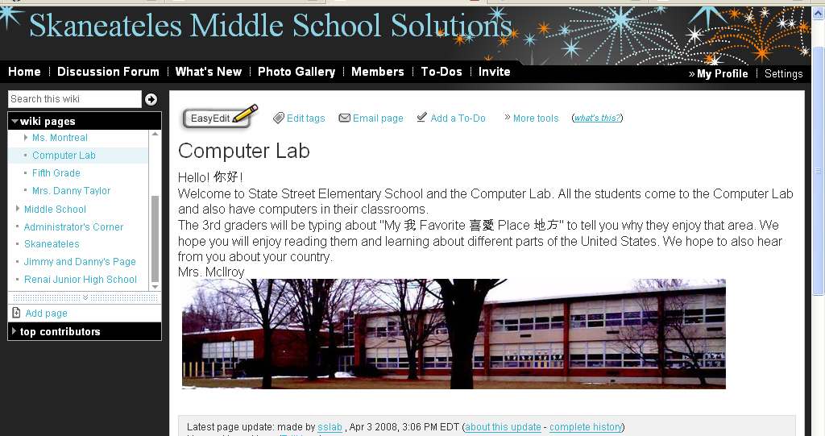
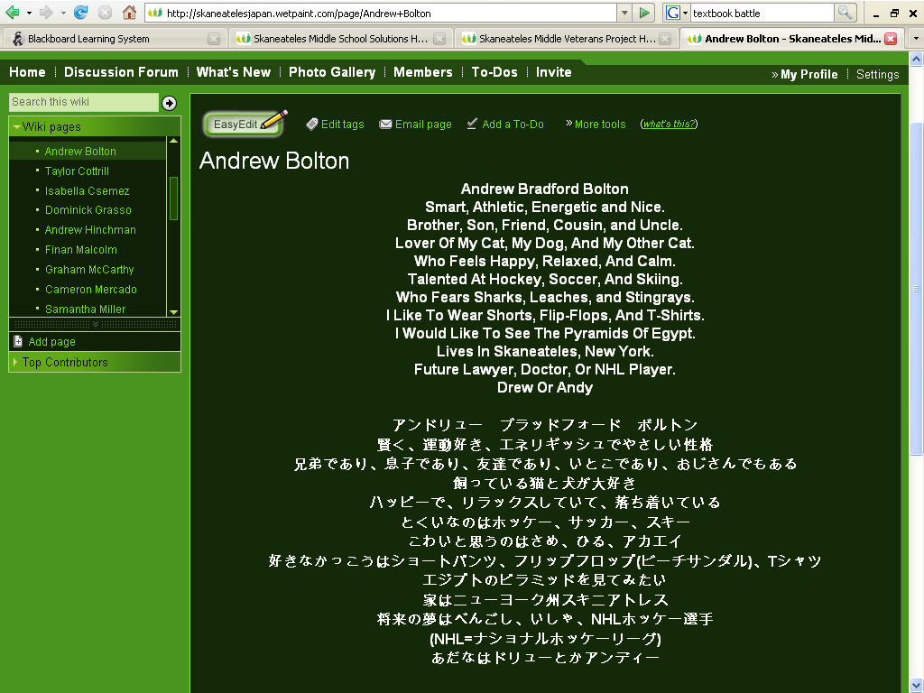

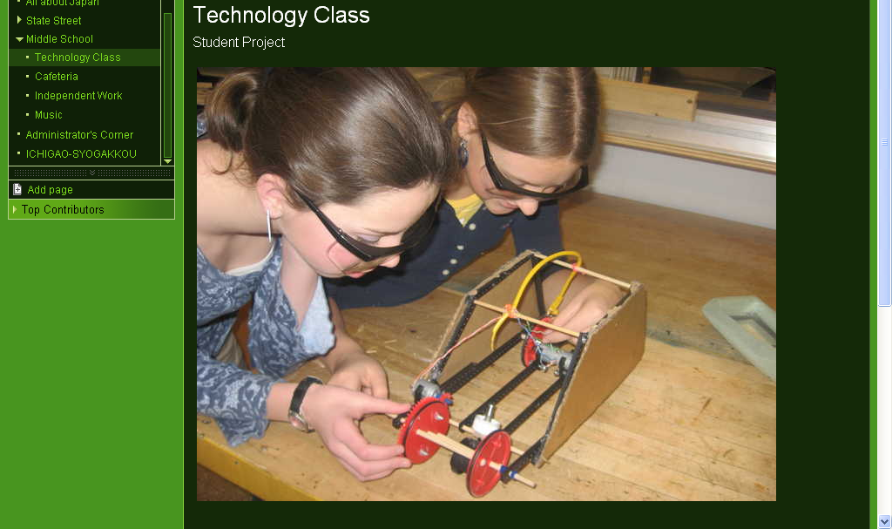

Technologies Used
A number of technologies were used for this project: wikis, images, blog entries, and videos. Please see the screen shots below for some examples of these technologies.
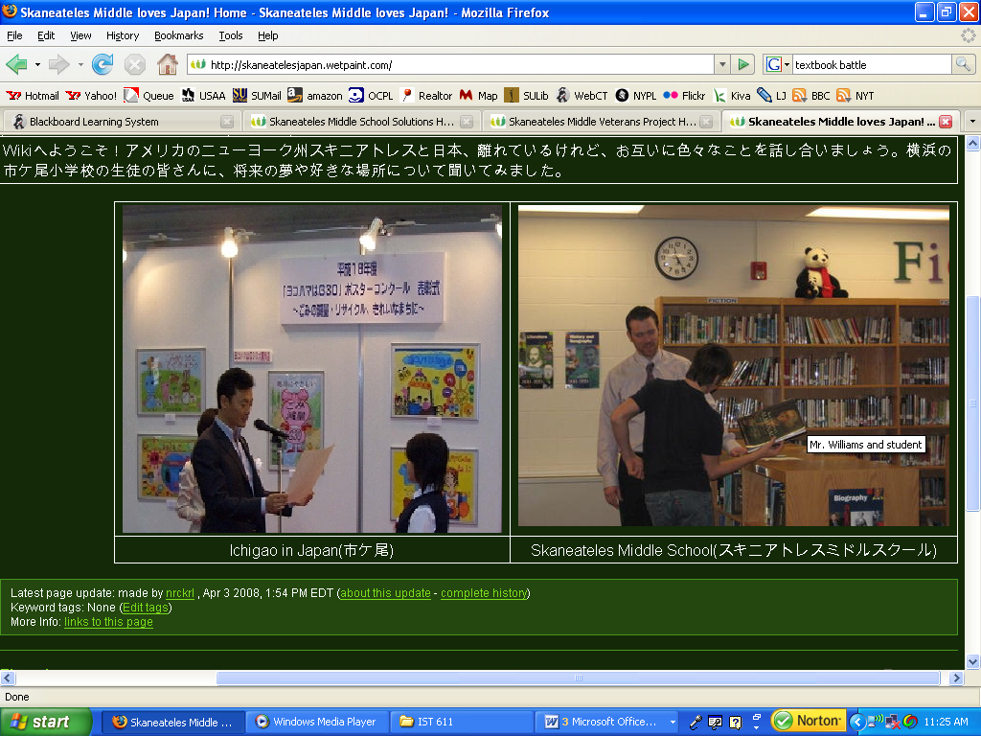

These photos compare classrooms in Yokohama, Japan and Skaneateles, NY. Note that schools will try to translate wiki pages into both languages.

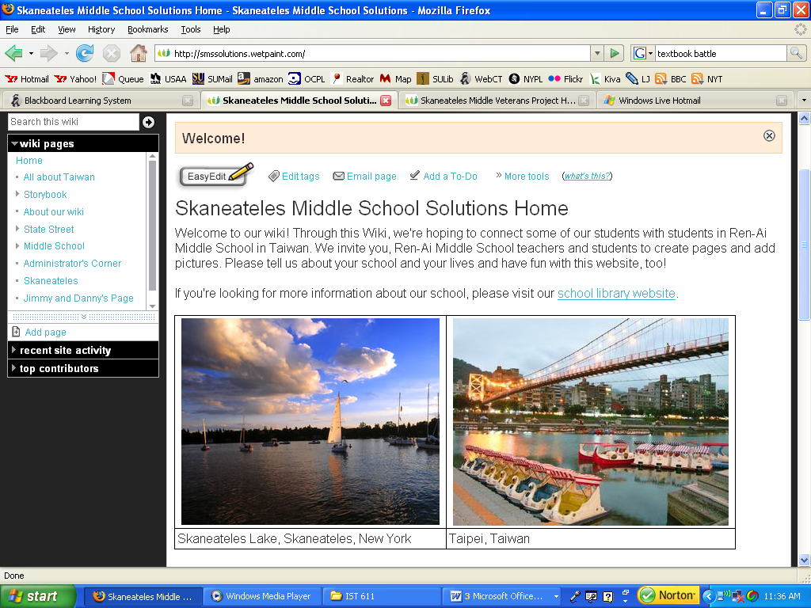

These photographs compare water views from Taipei, Taiwan and Skaneateles, NY.

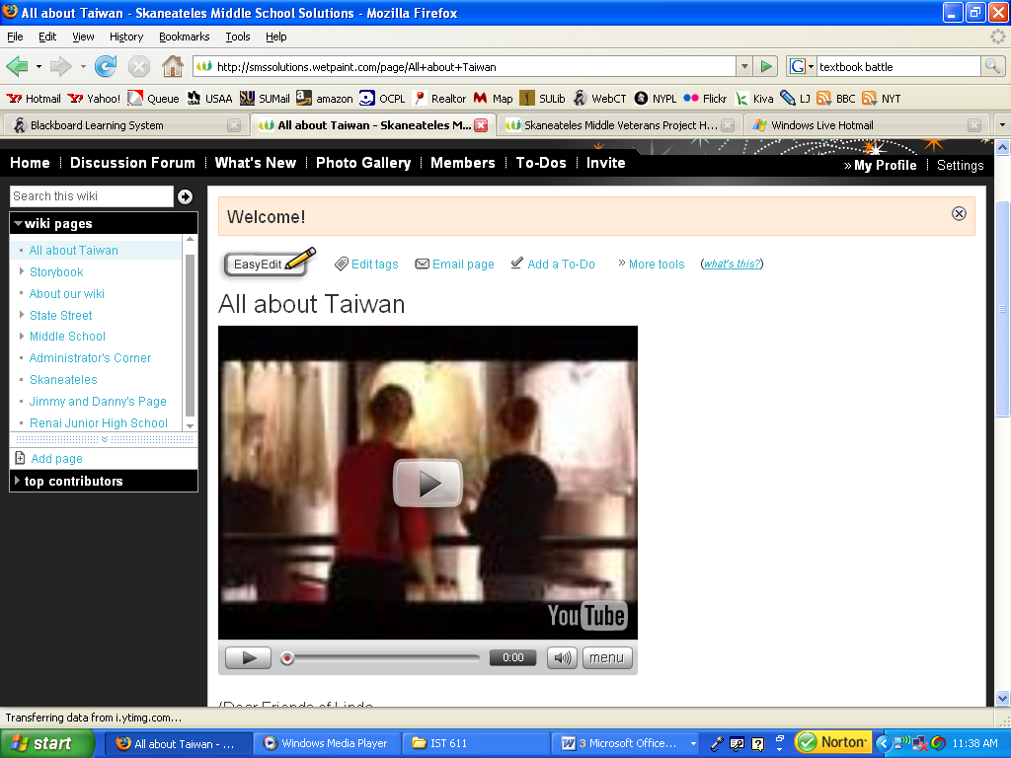

We embedded a YouTube video about Taiwan on our country introduction page.

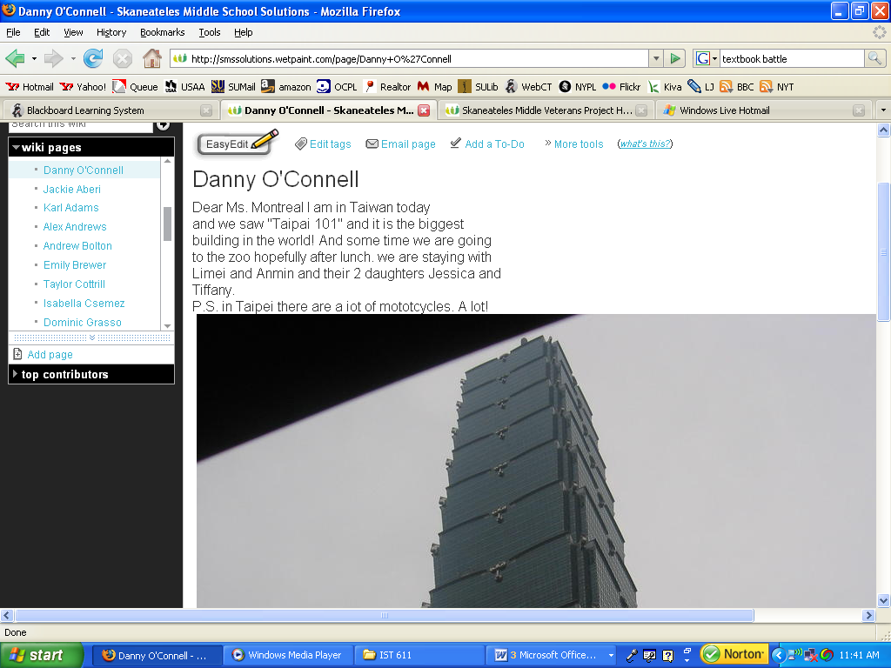

Danny O’Connell, Sharon’s son, is blogging to his classmates during their trip (this post was from Thursday, April 10).

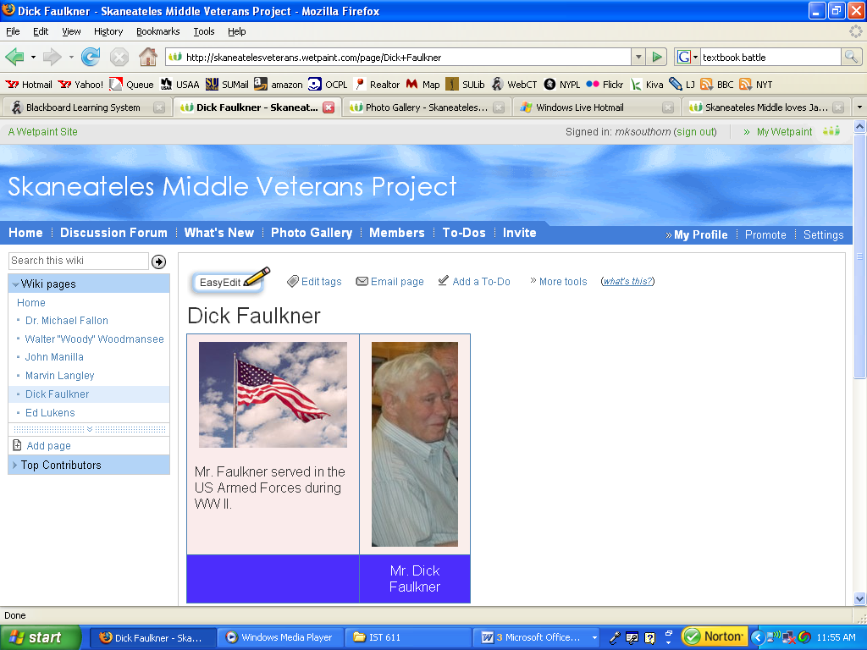

Eventually, each veteran page will include a photograph of the veteran, a video for the interview, and hyperlinks related directly to their remarks. Three of the interviews have already taken place, with three more scheduled near Memorial Day in May. However, videos will not be posted until Christine has been able to fully edit out student faces, per Skaneateles School District privacy policies.
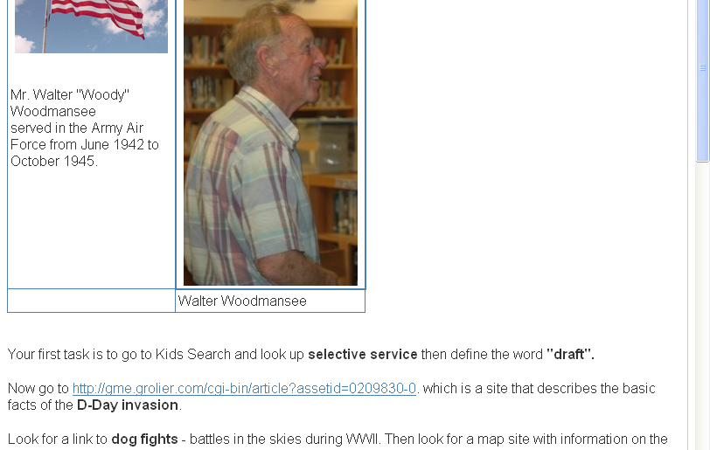

Above, the teachers pulled out specific points Woody discussed during his interview, and have been adding hyperlinks to help students research and understand these points.

Challenges Faced
We faced a number of challenges during this project.

Challenge One: Which wiki application should we choose?
There are a number of free wiki applications available: Wikispaces, PB Wiki, and Wikimedia are a few providers. We chose Wetpaint for several reasons, including:
- Appearance. The Wetpaint interface offers many options for vividly colored, interesting pages, while many of the other applications provide more of a no-frills look. We felt that this age group, in particular, would value the bright, cheerful look of Wetpaint. This area became more important as we ended up creating more than one wiki; we wanted each page to have a very different look so students would have no problem recalling which page had what content. The original page has a fireworks design (celebrating Chinese culture!). We chose blue and white for the veterans page, and a dark green appearance for Japan.
- Security. Wetpaint makes it extremely easy to modify your security and privacy to a wide variety of levels, from fully open with anonymous contributors to completely locked down with invited members only. See challenge three below for more on this topic.
- While all of the wiki applications offered a chance to make the wiki ad-free (an important requirement for keeping the site safe for our students), the Wetpaint process was very easy – just an email listing our school info and objectives, and viola! Ads were removed within 48 hours.
- Administrator tools such as site statistics and page histories are not located in a prominent area of the wiki interface. We did not want to overwhelm students who might click on this data and become distracted from the core wiki activities.
- Wetpaint offered interesting pre-created templates for pages and profiles, reducing the workload for teaching staff. For example, each new page automatically includes a discussion space. Other wikis separate discussion spaces from individual pages, and force you to create them manually.
- Wetpaint offers more click-through options on each page, which makes it easier for training teachers to “do things” to the pages. For example, while wikispaces requires you to go to the “manage pages” area to move pages, Wetpaint allow you to do this using a tool available on every page in the same spot.
- Trainer familiarity. I used Wetpaint for CNY Library Camp, and was simply comfortable with the interface and options available. Christine and Sharon liked that this application was fresh in my mind, in contrast to my use of other applications from a year or two back. This was a very subjective, but nonetheless convincing, point.

Challenge Two: Using the wiki
Wikis are still uncharted territory in many schools. Many of the teachers at SMS were either a) unfamiliar with or b) somewhat afraid of using a wiki. We decided to overcome this obstacle by holding a hands-on workshop about using the wiki. Turn-out was low, but Sharon and Christine were confident that they could model my training techniques with other teachers on a one-on-one basis. I also shared with them a “Wiki Pedagogy” article that nicely summarized many ways a wiki can positively contribute to the classroom, hoping that this would give them some support for their wiki advocacy.

Challenge Three: Privacy issues
Schools have stringent privacy requirements, and students would also be learning Internet safety as part of this project. We wanted to ensure that students would retain anonymity under school requirements, yet be able to share their words and photos within a school-approved activity. We addressed this issue by separating the e-pal and veterans elements into separate wikis.

The e-pal wikis are locked down as private, members-only wikis. This means that you cannot view anything on the sites unless you have been invited by a member of the site, and wiki administrators have full power to completely ban anyone who contributes inappropriately. Members have further been given read-only or read-and-write privileges, to keep participation in compliance with age requirements. Younger students can read the site and enjoy watching their older schoolmates in action while conforming to Internet safety standards, and older students can fully contribute as wiki writers.

The veterans wiki is an open wiki, permitting everyone in the public to view the site. However, editing and contributions are locked down to members with writing privileges only. We decided to make this wiki public so that parents and anyone discovering the wiki through a Veterans History Project link could see how well the students have done at interviewing and connecting their interviewees’ experiences to history lessons. However, this has slowed down some of the activity on this site; Christine is personally reviewing every video and photo to ensure that no student faces are inadvertently posted on the public site.

Challenge Four: International relations
We initially planned to have students communicate with international friends on one wiki. However, Sharon and I discussed the fact that international politics might make this contentious. More specifically, some ethnic Chinese people harbor historically-based negative feelings for people of Japanese ethnicity. The Japanese government occupied a large circle of Asian territory during the latter part of the 19th century and the first half of the 20th century. As with any occupation, many cases of genocide and rebellion were documented during this time period. Groups in the region continue to argue over treatment of these incidents in the public eye and school history textbooks. Although we did not anticipate any truly biting remarks between groups, we wanted to prevent any possibility for ugly remarks stemming from this animosity.

Results
We are enormously pleased with the results of our wikis. Students are actively engaged in projects, and teachers have enjoyed using the project as a springboard for content area activities. My only regret is that I was unable to link this to a practicum assignment – integrating such an engaging and complex project into my physical location would have allowed me to become more integrated into the project and to dedicate more time to supporting it. However, my partners in the project are extremely pleased with the results and were quite content with the time I could give them. A high point of interaction was the casual how-to-wiki workshop I gave at SMS. This ensured that staff members felt comfortable with asking me questions and keeping in touch with me in case any further questions popped up later.

Reflection
The project has been a totally win-win situation, and probably my biggest success story among projects I’ve undertaken during classes in the MSLIS program. I gained experience working with a highly motivated and supportive school team, and in return they received my wiki knowledge. Other projects I’ve undertaken have involved these technologies, but at those locations I usually ended up flying solo at pushing forward the effort. This was unfortunate; no matter how great the content ended up, teachers did not see it as their own (even though it was their idea!), and I have no way to tell how much classes actually use the resources now. By contrast, SMS staff members have thoroughly embraced and adopted this effort as their own, which is exactly what a wiki should be. It has been absolutely thrilling to watch the wiki grow, to see new photos and activities posted, and to witness more and more teachers joining the wiki with new activities and ideas to share.

Completed Project Links
http://smssolutions.wetpaint.com/. This is our first wiki site, designed to facilitate communications between SMS and Renai (Taiwan) students. It is a members-only site.
http://skaneatelesveterans.wetpaint.com/. This our second wiki site, and provides public access. Unfortunately, this is also the site with the least content, since we must comply with student privacy requirements.
http://skaneatelesjapan.wetpaint.com/. This is our third wiki site, designed to facilitate communications between SMS and Ichigao-Syogakkou (Japan) students. It is a members-only site.

Works Cited
Fountain, Renee. “Wiki Pedagogy.” Dossiers technopedagogiques. Crepuq: Conferences des Recteurs et des Prinipaux des Universites du Quebec. 2005. 5 Mar. 2008. <http://www.profetic.org/dossiers/dossier_imprimer.php3?id_rubrique=110>

O’Connell, Sharon and Christine Dickerson. Middle School Solutions! Technology Proposal. Unpublished BOCES Grant Application. 31 Jan. 2008.

Veterans History Project, American Folklife Center, Library of Congress. “How to Participate: Especially for Educators and Students.” Veterans History Project Youth Resources. 9 Nov. 2007. 4 Feb. 2008. <http://www.loc.gov/vets/youth-resources.html>

If you are curious about this issue, you can view coverage all over the web in a multitude of media outlets and scholarly journals. See, for instance, “Nobel laureate wins court battle over Japanese atrocities.” Associated Press. 28 Mar. 2008. <http://books.guardian.co.uk/news/articles/0,,2268915,00.html.>
Steve, if you’d like me to invite you into the members-only sites, please let me know.

